

BV Double Choc Chip Muffin, 4.0 oz, SKU# 60960 (IW)

Nutrition Facts | Total Fat 13 g 20% Total Carbohydrate 61 g 20%  Sat Fat 3 g 15% Fiber 3 g 12%  Trans fat 0 g Sugars 23 g  Cholesterol 45 mg 15% Protein 5 g  Sodium 400 mg 17%
Amt/Serving size; 4.0 oz
(113 grams)
Servings Size: 1 Muffin
Calories 390
Calories from Fat 120
Vit A – 2% * Vit C – 0% * Calcium – 2% * Iron – 25%

Ingredients:

Enriched Flour (Wheat Flour, Malted Barley Flour, Niacin, Iron, Thiamin Mononitrate, Riboflavin, Folic Acid), Sugar, WATER, Chocolate Chips (Sugar, Chocolate Liquor, Cocoa Butter, Soy Lecithin (an emulsifier), Vanilla, salt), EGGS (with citric acid as a preservative), canola oil, COCOA (PROCESSED WITH ALKALI), Food starch-modified, whey, Leavening (sodium acid pyrophosphate, sodium bicarbonate, corn starch, monocalcium phosphate), SALT, Natural vanilla flavor (Glycerin, alcohol, water, sugar, natural flavors (including vanilla bean extractives), propylene glycol)

CONTAINS: Milk, Egg, SOY, WHEAT

Bread Servings: (113 X 0.318)/14.75 = 2.43 Breads (rounds Down to 2.25 breads)

Breads | Fruit/Vegetable | Protein
2.25 | Na | Na

I certify that the above information is true and correct.
6/1/2011 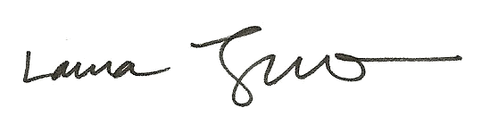
Date Laura Trujillo, RD, SNS

